Exp-1
Aim
To design an interactive diagram illustrating the components of a basic cellular system using Figma and demonstrate their functions through clickable prototype interactions.
Procedure
- Open Figma and create a new design file.
- Create a diagram titled Components of a Basic Cellular System.
- Add the Mobile Station (MS), Base Transceiver Station (BTS), Base Station Controller (BSC), Mobile Switching Centre (MSC), Subscriber Databases, and External Telephone Network.
- Connect the components using arrows and label the communication interfaces.
- Create a separate frame containing an explanation of each component.
- Use the Prototype tab to connect the component cards to their corresponding explanation frames with click interactions.
- Run the prototype using the Present button and verify that the interactions work correctly.
Screenshot:
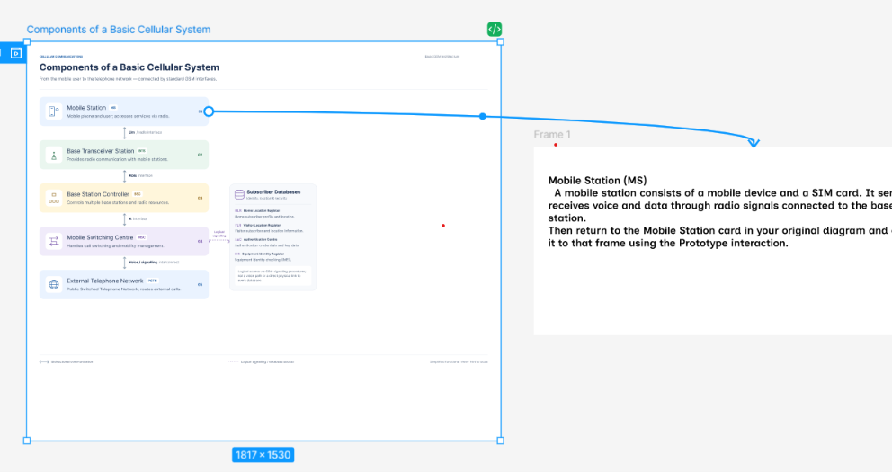
Result
Successfully designed and tested an interactive cellular system diagram in Figma, illustrating the major components, their communication links, and their functions through clickable prototype interactions.

